Pengolahan Citra

**5. Filtering LPH dan HPF in domain frequency**

**Dosen Pengampu**

Hero Yudo Martono ST, MT



**Disusun Oleh :**

Nama : M. Faza Nur Husain

Nrp : 3121550004

**D3 PJJ AK TEKNIK INFORMATIKA**

**POLITEKNIK ELEKTRONIKA NEGERI SURABAYA**

**TAHUN AKADEMIK 2021/2022**

**Source Code :**

def spektrum():

    img = cv2.imread('gambar/kuda.jpg', 0)

    img_float32 = np.float32(img)

    dft = cv2.dft(img_float32, flags=cv2.DFT_COMPLEX_OUTPUT)

    dft_shift = np.fft.fftshift(dft)

    magnitude_spectrum = 20 * \

        np.log(cv2.magnitude(dft_shift[:, :, 0], dft_shift[:, :, 1]))

    plt.subplot(121), plt.imshow(img, cmap='gray')

    plt.title('Input Image'), plt.xticks([]), plt.yticks([])

    plt.subplot(122), plt.imshow(magnitude_spectrum, cmap='gray')

    plt.title('Magnitude Spectrum'), plt.xticks([]), plt.yticks([])

    plt.show()

    return

def spektrum2():

    img = cv2.imread('gambar/kuda.jpg', 0)

    f = np.fft.fft2(img)

    fshift = np.fft.fftshift(f)

    magnitude_spectrum = 20*np.log(np.abs(fshift))

    plt.subplot(121), plt.imshow(img, cmap='gray')

    plt.title('Input Image'), plt.xticks([]), plt.yticks([])

    plt.subplot(122), plt.imshow(magnitude_spectrum, cmap='gray')

    plt.title('Magnitude Spectrum'), plt.xticks([]), plt.yticks([])

    plt.show()

    return

def afterhpfjet():

    img = cv2.imread('gambar/kuda.jpg', 0)

    f = np.fft.fft2(img)

    fshift = np.fft.fftshift(f)

    magnitude_spectrum = 20*np.log(np.abs(fshift))

    rows, cols = img.shape

    crow, ccol = int(rows/2), int(cols/2)

    print(crow, ccol)

    fshift[crow-30:crow+30, ccol-30:ccol+30] = 0

    f_ishift = np.fft.ifftshift(fshift)

    img_back = np.fft.ifft2(f_ishift)

    img_back = np.abs(img_back)

    plt.subplot(131), plt.imshow(img, cmap='gray')

    plt.title('Input Image'), plt.xticks([]), plt.yticks([])

    plt.subplot(132), plt.imshow(img_back, cmap='gray')

    plt.title('Image after HPF'), plt.xticks([]), plt.yticks([])

    plt.subplot(133), plt.imshow(img_back)

    plt.title('Result in JET'), plt.xticks([]), plt.yticks([])

    plt.show()

    return

def spektrum3():

    img = cv2.imread('gambar/kuda.jpg', 0)

    dft = cv2.dft(np.float32(img), flags=cv2.DFT_COMPLEX_OUTPUT)

    dft_shift = np.fft.fftshift(dft)

    rows, cols = img.shape

    crow, ccol = int(rows/2), int(cols/2)

    # create a mask first, center square is 1, remaining all zeros

    mask = np.zeros((rows, cols, 2), np.uint8)

    mask[crow-30:crow+30, ccol-30:ccol+30] = 1

    # apply mask and inverse DF1

    fshift = dft_shift*mask

    f_ishift = np.fft.ifftshift(fshift)

    img_back = cv2.idft(f_ishift)

    img_back = cv2.magnitude(img_back[:, :, 0], img_back[:, :, 1])

    plt.subplot(121), plt.imshow(img, cmap='gray')

    plt.title('Input Image'), plt.xticks([]), plt.yticks([])

    plt.subplot(122), plt.imshow(img_back, cmap='gray')

    plt.title('Magnitude Spectrum'), plt.xticks([]), plt.yticks([])

    plt.show()

    return

def lapsobel():

    img = cv2.imread("gambar/kuda.jpg", 0)

    laplacian = cv2. Laplacian(img, cv2.CV_64F)

    sobelx = cv2.Sobel(img, cv2.CV_64F, 1, 0, ksize=5)

    sobely = cv2.Sobel(img, cv2.CV_64F, 0, 1, ksize=5)

    plt.subplot(2, 2, 1), plt.imshow(img, cmap='gray')

    plt.title('Original'), plt.xticks([]), plt.yticks([])

    plt.subplot(2, 2, 2), plt.imshow(laplacian, cmap='gray')

    plt.title('Laplacian'), plt.xticks([]), plt.yticks([])

    plt.subplot(2, 2, 3), plt.imshow(sobelx, cmap='gray')

    plt.title('Sobel X'), plt.xticks([]), plt.yticks([])

    plt.subplot(2, 2, 4), plt.imshow(sobely, cmap='gray')

    plt.title('Sobel Y'), plt.xticks([]), plt.yticks([])

    plt.show()

    return

def hpffilter():

    # simple averaging filter without scaling parameter

    mean_filter = np.ones((3, 3))

    # creating a guassian filter

    x = cv2.getGaussianKernel(5, 10)

    gaussian = x*x.T

    # different edge detecting

    # scharr in x-direction

    scharr = np.array([[-3, 0, 3],

                       [-10, 0, 10],

                       [-3, 0, 3]])

    # sobel in x direction

    sobel_x = np.array([[-1, 0, 1],

                       [-2, 0, 2],

                       [-1, 0, 1]])

    # sobel in y direction

    sobel_y = np.array([[-1, -2, -1],

                       [0, 0, 0],

                       [1, 2, 1]])

    # :Laplacian

    laplacian = np.array([[0, 1, 0],

                         [1, -4, 1],

                          [0, 1, 0]])

    filters = [mean_filter, gaussian, laplacian, sobel_x, sobel_y, scharr]

    filter_name = ['mean filter', 'gaussian', 'laplacian', 'sobel_x',

                   'sobel_y', 'scharr_x']

    fft_filters = [np.fft.fft2(x) for x in filters]

    fft_shift = [np.fft.fftshift(y) for y in fft_filters]

    mag_spectrum = [np.log(np.abs(z)+1) for z in fft_shift]

    for i in range(6):

        plt.subplot(2, 3, i+1), plt.imshow(mag_spectrum[i], cmap='gray')

        plt.title(filter_name[i]), plt.xticks([]), plt.yticks([])

    plt.show()

    return

**Output :**

spektrum()

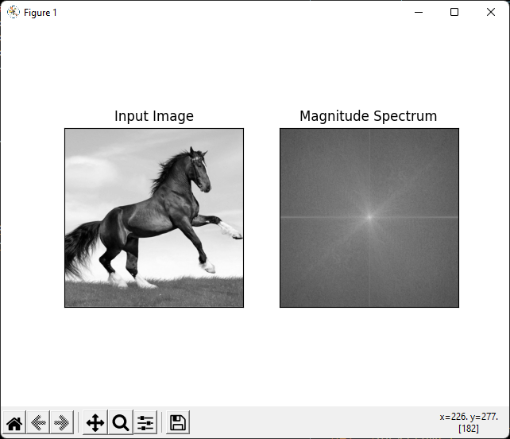

spektrum2()

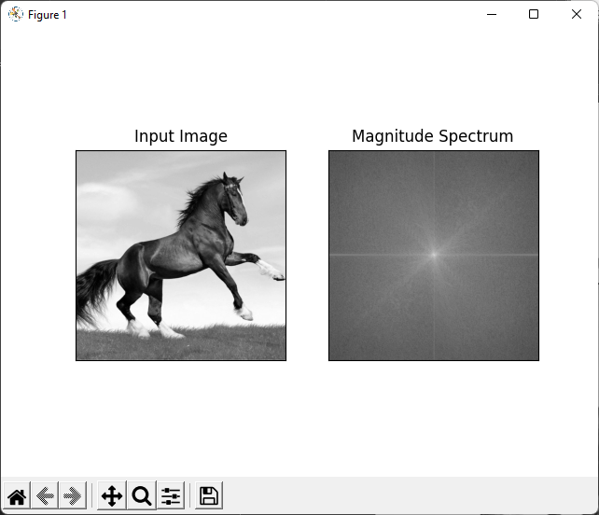

spektrum3()

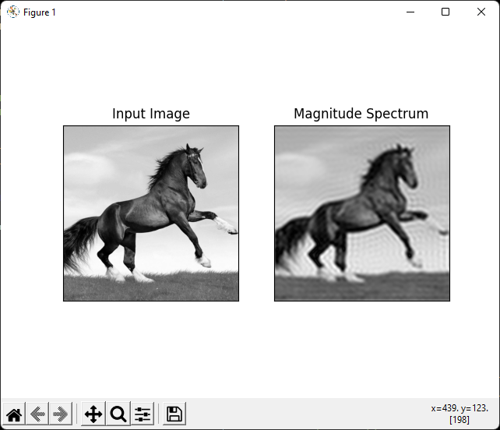

afterhpfjet()

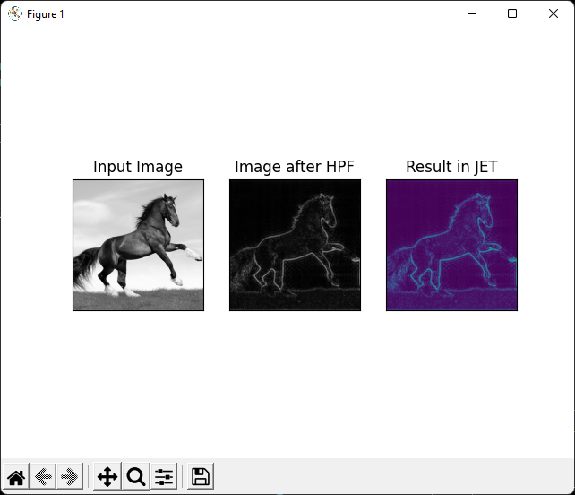

lapsobel()

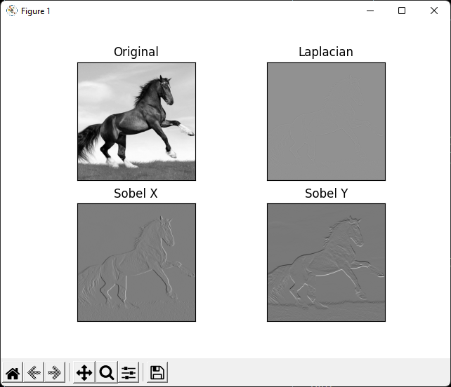

hpffilter()

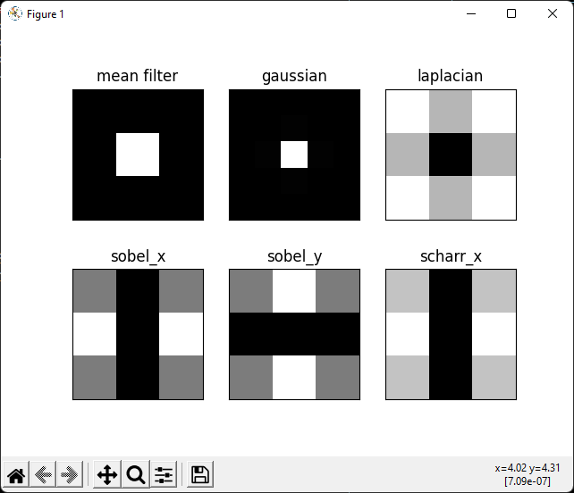

https://github.com/FazaZas/pengolahan_citra.git